
Name: Abdul Haseeb
Program: BSSE Group A
Semester: 5th
Date: October 16, 2026
*-----------------------------------------------*

Lab Task 7
Point to Point Topology and Bus Topology:

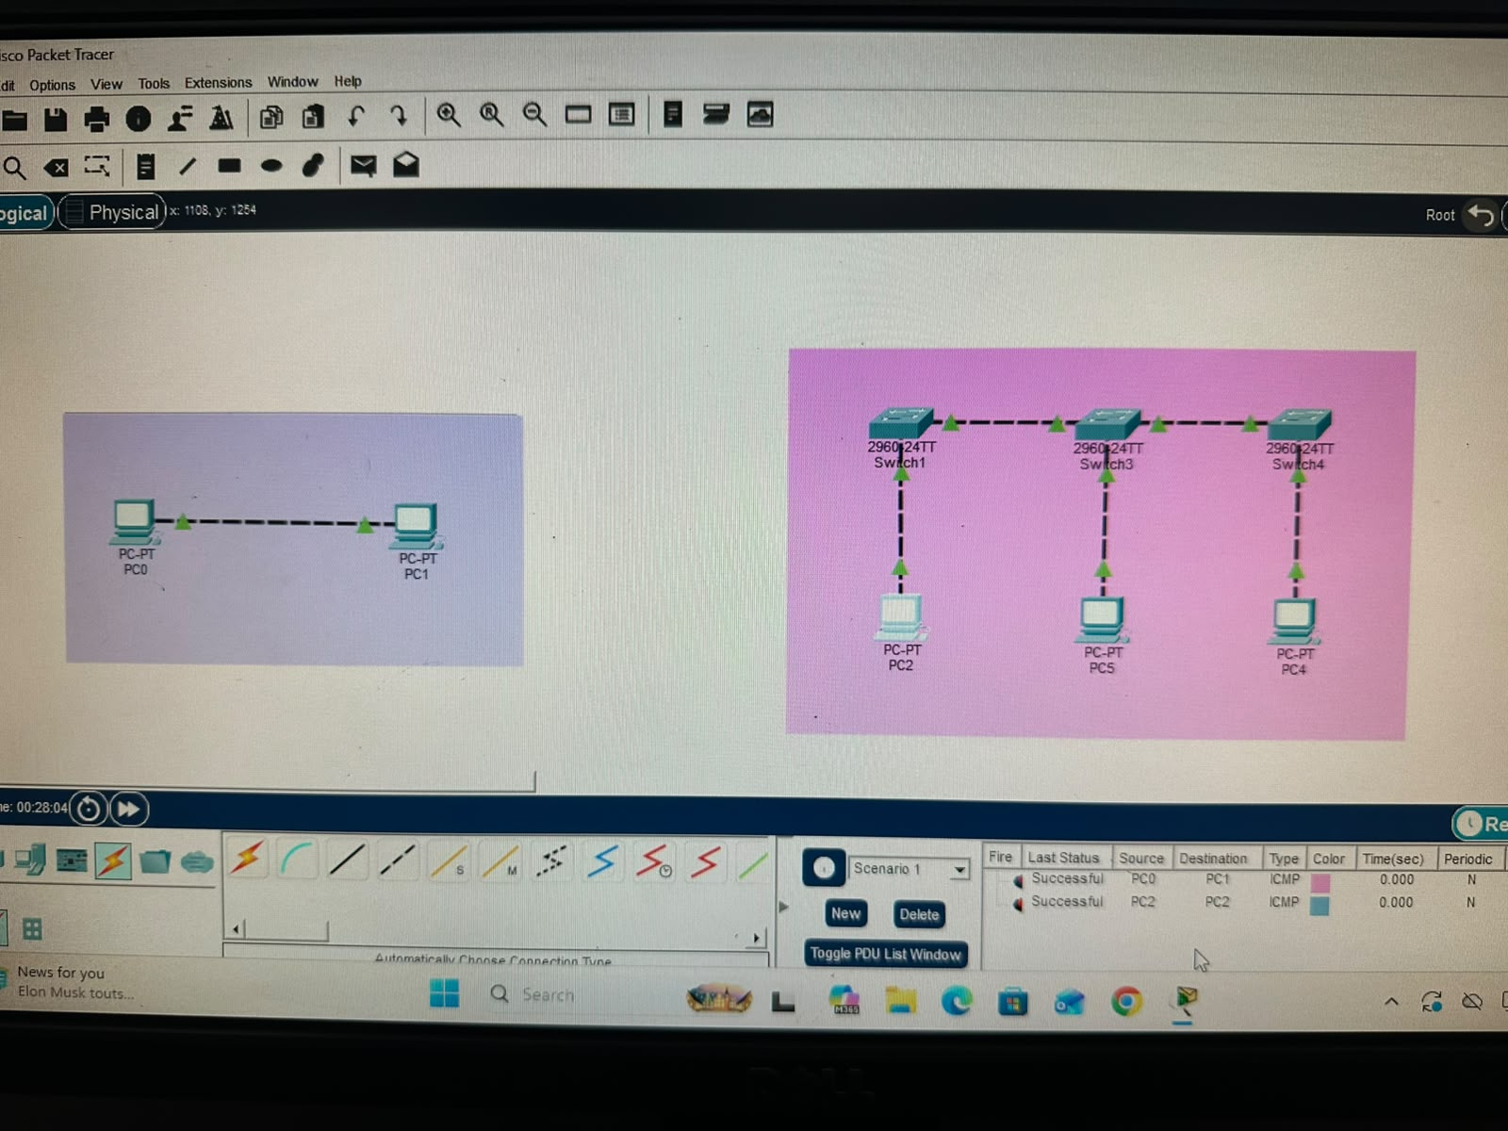

Star Topology:
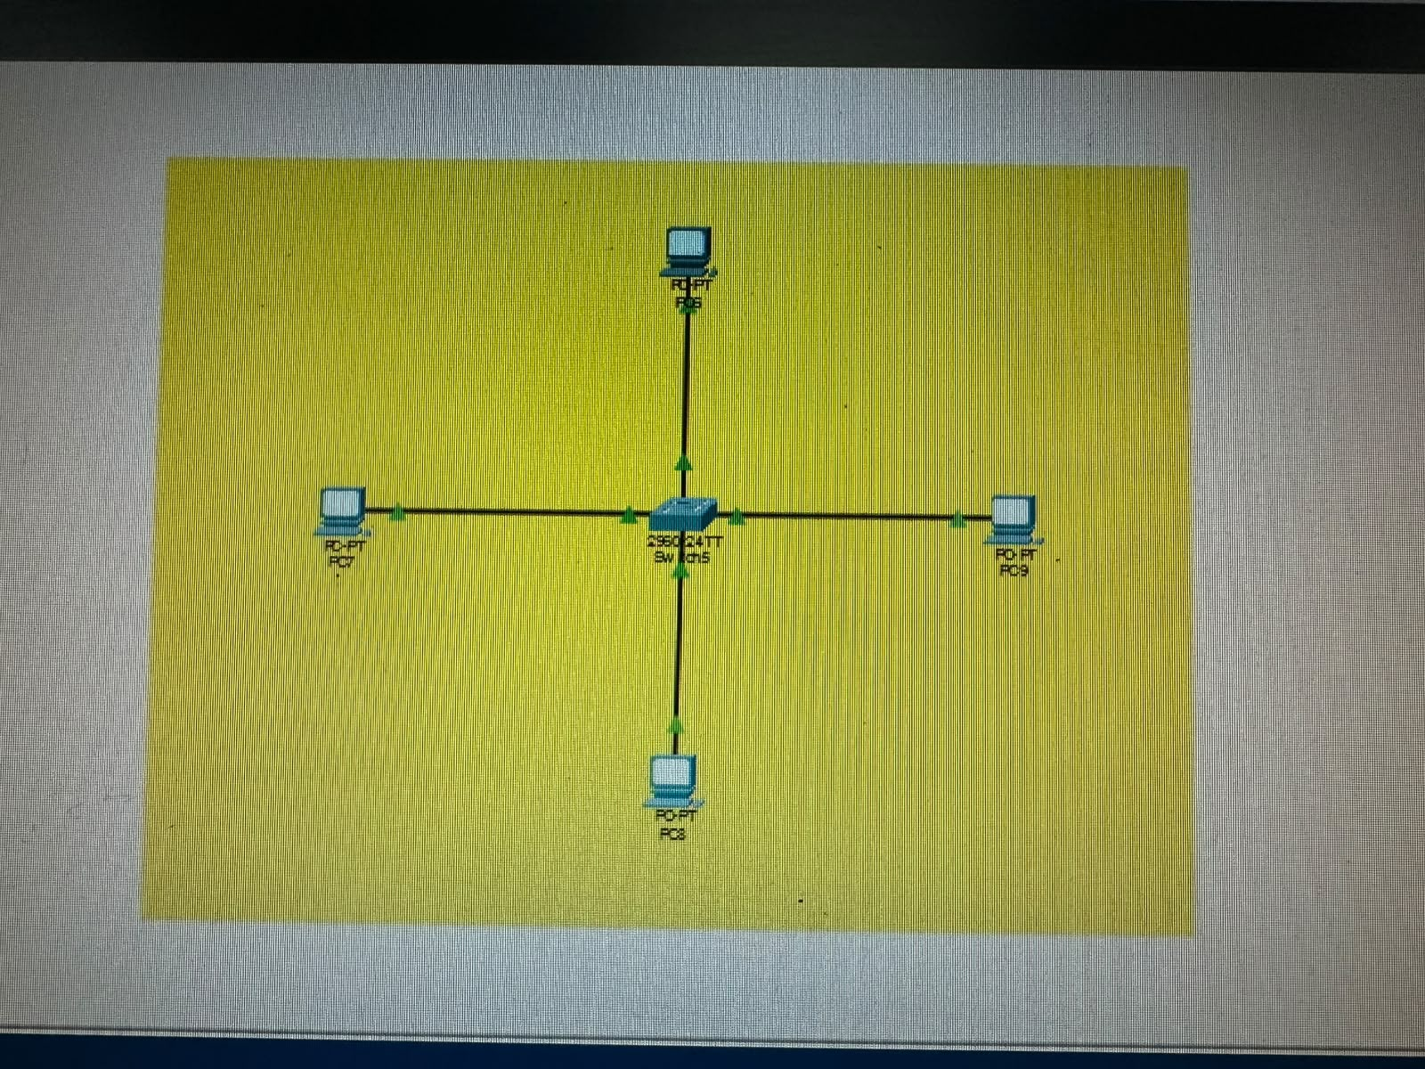

Ring Topology and Mesh Topology:
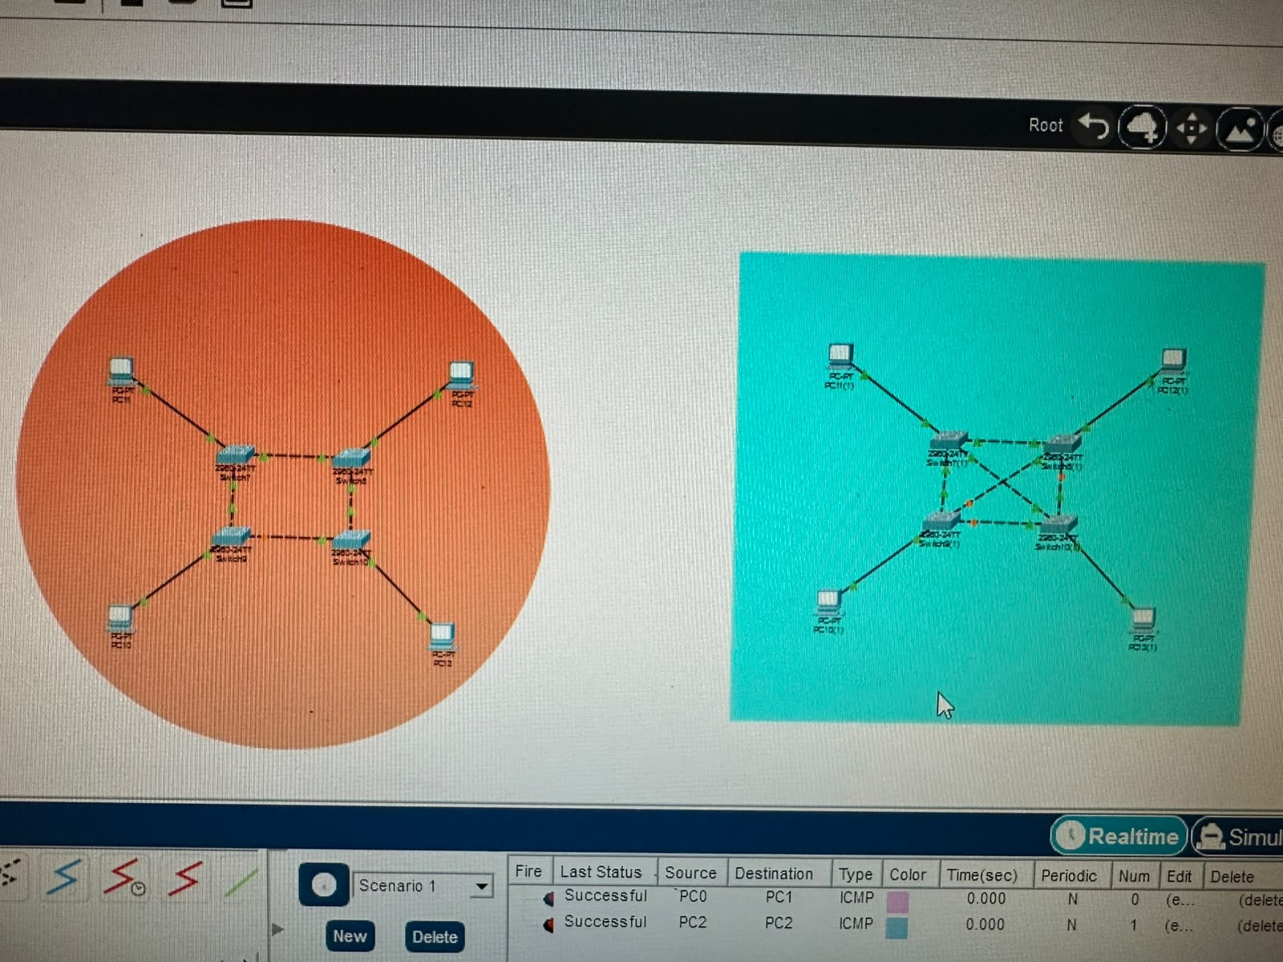

*-----------------------------------------------*

The End

